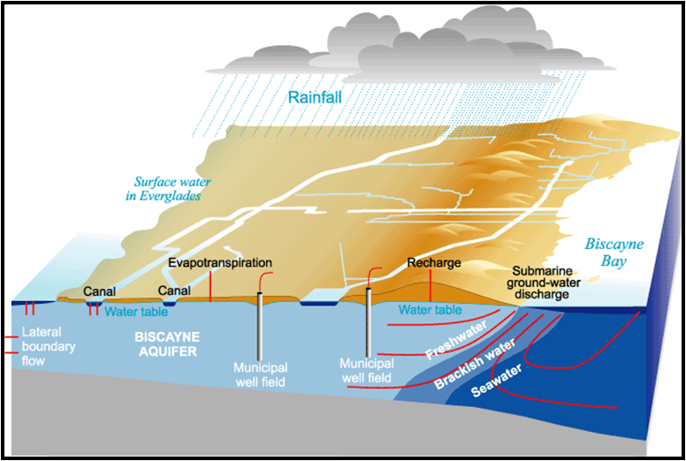

Conceptual Sketch of the Biscayne Aquifer

