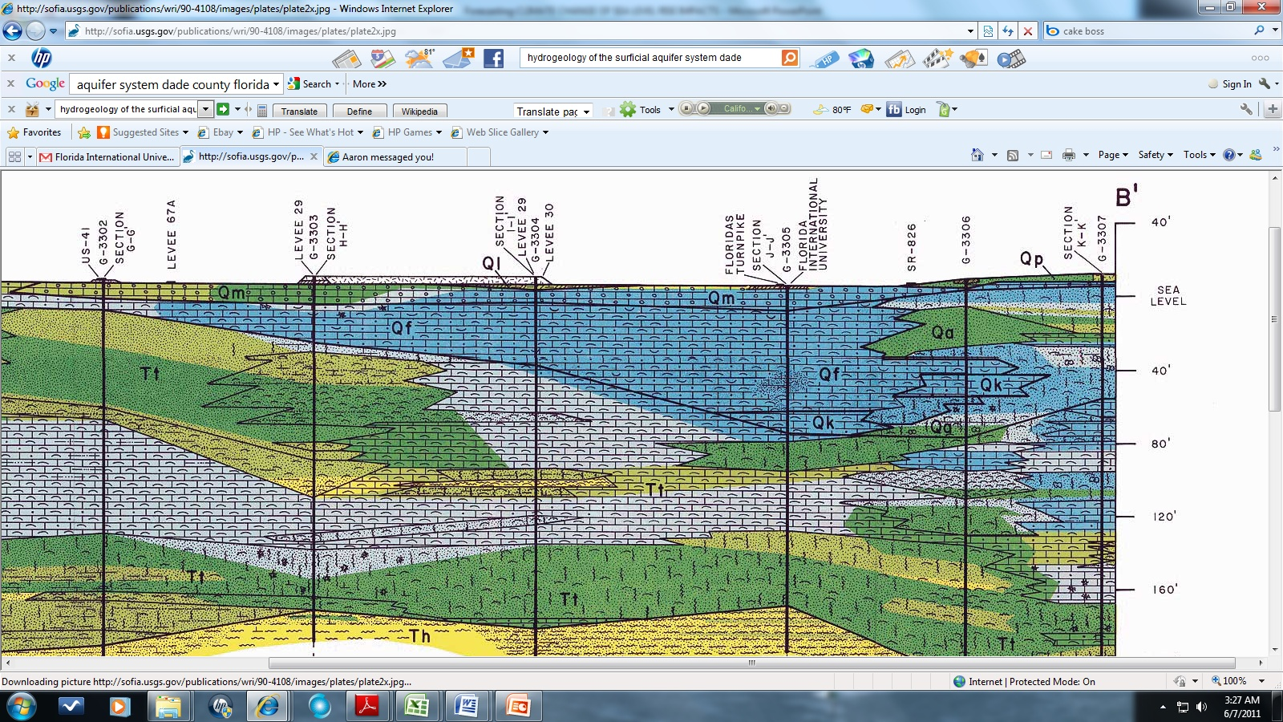

Typical Geological Cross Section of Biscayne Aquifer in MDC (SFWMD, 1991)

