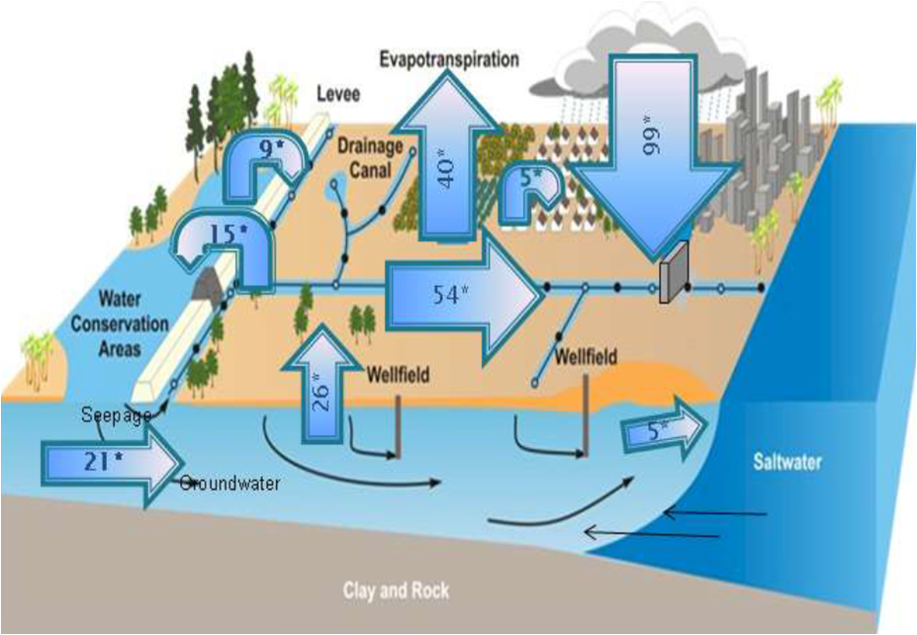

South Florida Water Balance Budget for 1965-2000. (Heimlich et al., 2009)